Jatin Chowdhary [400033011]

Lab Mates: Ameer & Dan

Lab Instructor: Christine

Date: March 21th, 2017

Biology Lab #4

**Abstract**

This article analyzes the respiratory function of the human body. In particular it examines the control mechanisms involved in regulating O2 and CO2 levels. The results indicate that vital capacity is larger than tidal volume due to vital capacity serving a purpose similar to a reserve tank. Furthermore, for the subject, breathing frequency rapidly dropped when asked to perform a mentally stressful exercise. In addition, breathing was affected by type of breathing, inhalation, and exhalation. In conclusion, breathing is affected at both a conscious and unconscious level.

**Introduction**

This experiment measures the several aspects of the respiratory function in the human body and gain some important insight. This experiment explores the delivery of O2 and removal of CO2 from the tissues and body. It is accomplished by recording the breathing patterns under specific conditions of the same subject. These conditions include quiet breathing, hyperventilation, breath holding, breathe concentration, and breathing after an intense exercise. Measurements are consistently recorded for these conditions. The respiratory system plays a vital role in monitoring and altering the partial pressures of O2 and CO2 throughout the lungs and body (Chiari et al). The respiratory system also controls the rate and depth of respiration. Breathing is controlled by the medulla oblongata, the pons, and the midbrain. The medulla oblongata detects CO2 and O2 levels in the blood and accordingly reacts to it by sending signals to the muscles in the heart, and in the diaphragm, and innervate them by signalling them to speed up or slow down (Chiari et al). Furthermore, it is anticipated that a subject at rest will have a relatively neutral breathing rate, while the same subject participating in an intense exercise will have an elevated breathing rate. Also, the subject will be panting through their mouth to increase the intake of oxygen and expel carbon dioxide along with other waste products. The respiratory system will be working harder.

**Materials & Method**

Refer to Biology 2A03 Lab Manual #4 – Human Respiratory Physiology – Published in 2017, for more information about materials and the method used to execute this lab. No changes were made to the experiment.

**Sample Calculations**

Average For Exercise 1: Breathing [Normal]

(2.153 + 1.625 + 1.747 + 1.037 + 1.060) / 5 = 1.5244 L

Sample Standard Error For Exercise 1: Breathing [Normal]

S = 2) / n – 1 = 0.47645 L

Sample Standard Error For Exercise 1: Breathing [Normal]

0.47645 / (50.5) = 0.21307 L

Average For Exercise 2: Mental Concentration [Normal]

(0.71 + 0.73 + 0.694 + 0.797 + 0.663) / 5 = 0.7188 L

Sample Standard Error For Exercise 2: Mental Concentration [Normal]

S = 2) / n – 1 = 0.050117 L

Sample Standard Error For Exercise 2: Mental Concentration [Normal]

0.47645 / (50.5) = 0.015 L

Average For Exercise 3: Effect of Blood Gases On Breathing [Normal]

(0.895 + 0.788 + 0.845 + 0.684 + 0.628) / 5 = 0.768 L

Sample Standard Error For Exercise 3: Effect of Blood Gases On Breathing [Normal]

S = 2) / n – 1 = 0.110808 L

Sample Standard Error For Exercise 3: Effect of Blood Gases On Breathing [Normal]

0.47645 / (50.5) = 0.049555 L

Breathing Frequency = 60 [Secs/Min] / Average Breath Period [Secs/Breath] = 8.604618 [B/M]

**Results**

The results for this lab are based off the interpretation of a single subject. All results will be referenced relative to the subject. All Figures, one through nine, pertain to the subject’s respiratory data. Subject is male, 19 years of age, and 68 kilograms.

Figure 1 demonstrated the average tidal volume [in litres] and the vital capacity [also in litres] for subject after eupnea – normal, quiet breathing. The data was collected by having the subject respire through an SP-304 for approximately 10 full breathing cycles. The average tidal volume was 1.524 L with a standard deviation of 0.476. The average vital capacity was 3.20 L with a standard deviation of 0.400. On average, the average tidal volume is about 2.1 times less than the average tidal capacity.

Figure 2 demonstrated average breathing frequency [measured in breaths/min] for the subject after normal respiration and after maximum respiration, as subject was respiring through the SP-304. The average breathing frequency for normal respiration was 8.60 breaths/minute, with a standard deviation of 0.88, and after reaching vital capacity it was 6.51 breaths/minute with a standard deviation of 0.61. On average, normal respiration had 2.1 more breaths/minute than its counterpart, or 1.3 times more breaths/minute.

Figure 3 demonstrated the average tidal volume [in litres] for subject when asked to normally breathe, and breathe while simultaneously performing a mentally challenging activity – recite the alphabet backwards. The average tidal volume [in litres] for normal breathing was approximately 0.72 L with standard deviation of 0.05. And while performing a mentally challenging activity of reciting the alphabet backwards, subject’s respiration was approximately 0.68 L with a standard deviation of 0.21. The subject’s average tidal volume was approximately 1.05 times less when performing a mentally challenging activity, as compared to the subject’s regular, normal, breathing.

Figure 4 demonstrated the average breathing frequency [in breathes/min] for subject after normal, regular breathing and when breathing while simultaneously performing a mentally challenging activity. The average breathing frequency [in breathes/min] after normal and regular breathing was 19.74 breathes/min with a standard deviation of 1.65. On the other hand, the average breathing frequency while performing a mentally strenuous activity was 7.62 breathes/min with a standard deviation of 1.85. The average breathing frequency for the subject when normally respiring versus when performing a mentally strenuous activity was approximately 2.59 times higher, on average.

Figure 5 demonstrated the average tidal volume [in liters] for the subject when breathing normally, hyperventilating, and continuing to breathe after hyperventilating (re-breathing). The subject’s average tidal volume for normally breathing was 0.76 L with standard deviation of about 0.11. The subject’s average tidal volume while hyperventilating was 0.46 L with standard deviation of about 0.04. The subject’s average tidal volume after hyperventilating (re-breathing stage), was 1.45 L with standard deviation at 0.27. The subject’s average tidal volume differed for all three stages by factors of 1.67, 1.88, and 3.15. The average tidal volume while hyperventilating was 1.67 times less than the average tidal volume while normally respiring. And the average tidal volume just after hyperventilating was 1.88 times higher than the average tidal volume while normally respiring, and 3.15 times higher than while hyperventilating.

Figure 6 demonstrated the average breathing frequency (in breathes/min) for the subject during regular respiration, during hyperventilating, and immediately after hyperventilating (re-breathing stage). The subject’s average breathing frequency during regular respiration was 16.31 breathes/min with standard deviation of 0.98. The subject’s average breathing frequency during hyperventilation was 13.77 breathes/min with standard deviation of 2.02. The subject’s average breathing frequency during the re-breathing stage was approximately 26.0 breathes/min with standard deviation of 5.03. The breathing frequency during hyperventilation was 1.18 times lower than the breathing frequency during regular respiration. The breathing frequency during re-breathing was 1.89 times higher than during hyperventilation, and 1.59 times higher than normal breathing.

Figure 7 demonstrated the duration (in seconds) the subject was able to hold their breathe after changing up their inspiration and expiration styles. These styles include: normal inspiration, normal expiration, deep inspiration, and deep expiration. The subject was able to hold their breathe for 41.0 seconds after normally inspiring, 28.0 seconds after normally expiring, approximately 53.84 seconds after deeply inspiring, and 22.01 seconds after deeply expiring. The subject was able to hold their breathe for 12.84 seconds longer (1.3 times more) after deeply inspiring (compared to normal inspiration). The subject lasted approximately 6 seconds less (1.27 times less) after deeply expiring, when compared to normally expiring.

Figure 8 demonstrated the tidal volume [in liters] for subject, after exerting physical stress by pedalling on a bike for a total of 210 seconds. Immediately after the pedalling activity, the subject had a tidal volume of 0.48 L. This increased with time, settling to approximately 0.78 L after 200 seconds. From pedalling to rest, subject’s tidal volume increased by a factor of 1.63.

Figure 9 demonstrated the breathing frequency [in breaths/min] for subject after performing a physical strenuous activity of pedalling for 210 seconds. Breathing frequency after the pedalling activity was 57.1 breaths/min, and decreased to 21.20 breaths/min when the subject was rested for 210 seconds. From stress to rest, the subject’s breathing freq. decreased by a factor of 2.7

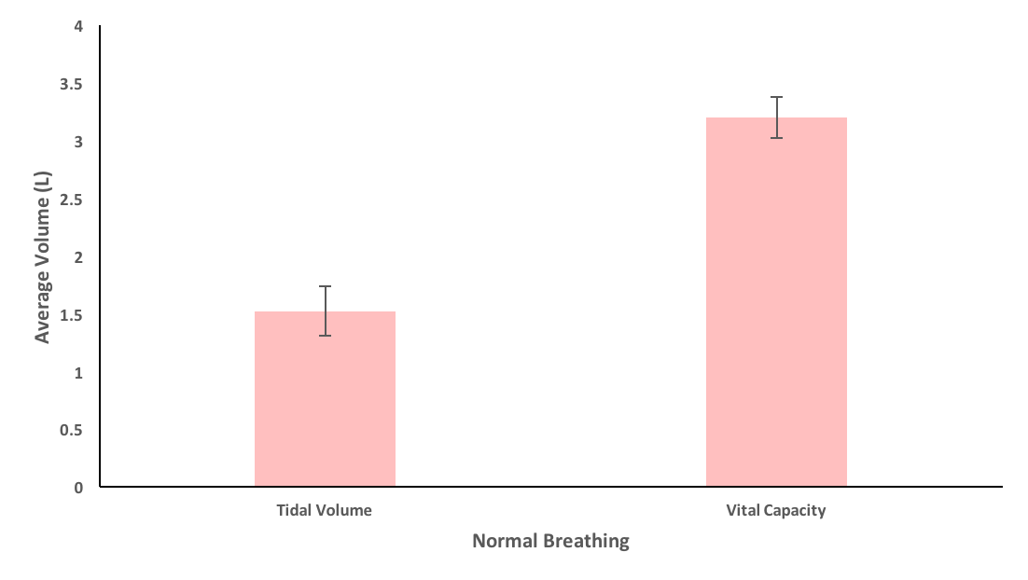

Eupnea

Figure 1: Bar graphs display average tidal volume (in liters) and vital capacity (also in liters) for subject after eupnea, as recorded by SP-304.

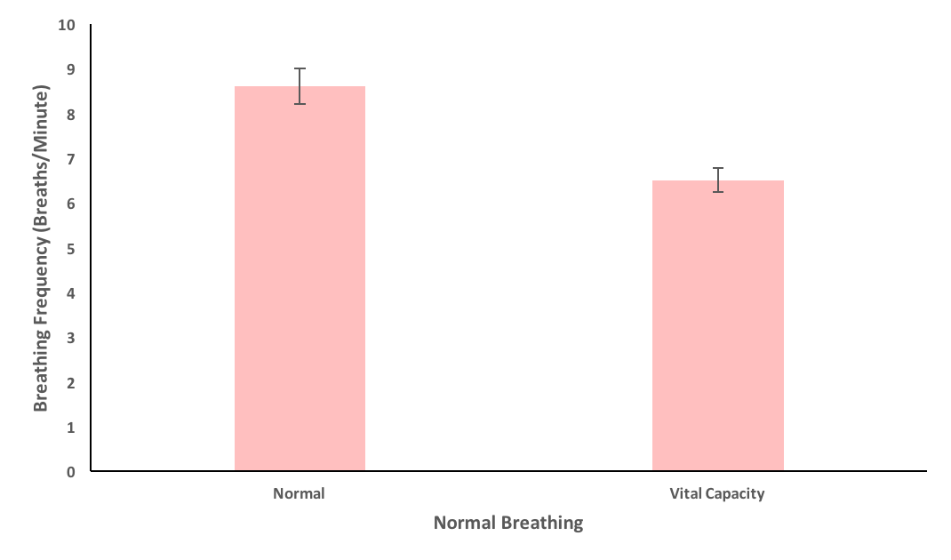

Eupnea

Figure 2: Bar graphs display average breathing frequency (in breaths/minute) for subject after normally and quietly breathing for a few minutes

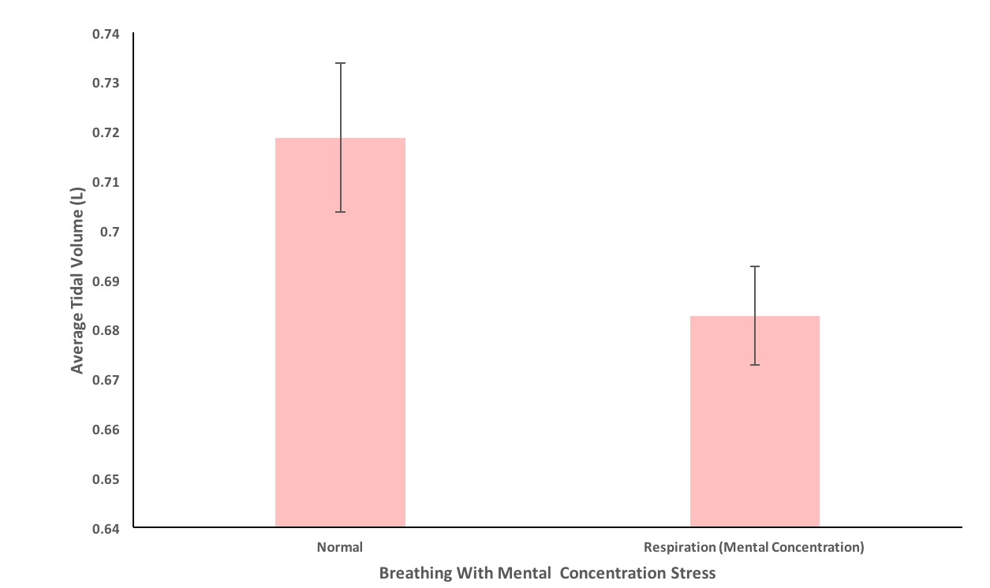

Figure 3: Bar graph displays average tidal volume (in liters) for subject after normal respiration and after performing a mentally intensive activity.

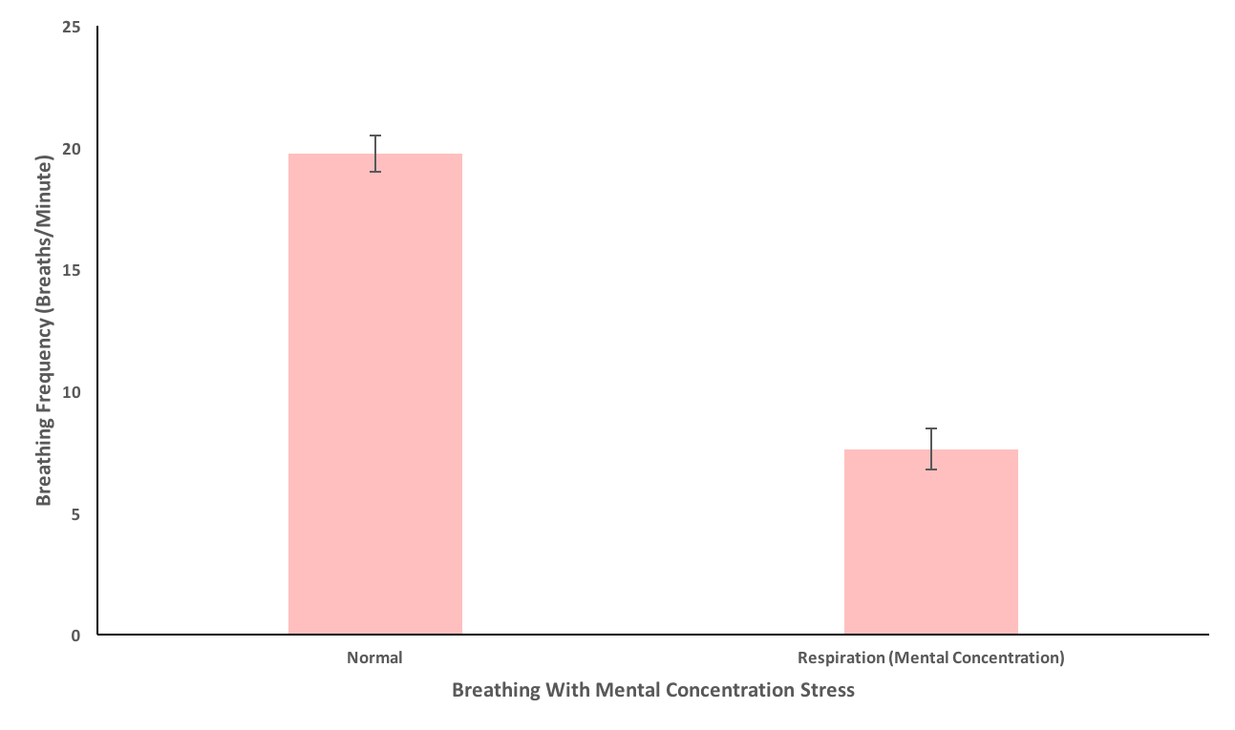

Figure 4: Bar graph displays average breathing frequency (in breaths/minutes) for subject after normal respiration and after performing a mentally intensive activity.

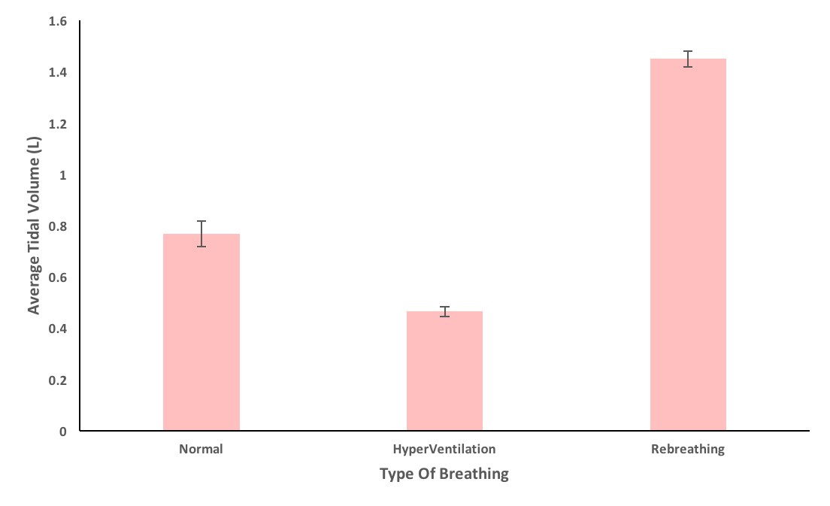

Figure 5: Bar graph displays average tidal volume (in liters) for subject after normally respiring, hyperventilating, and breathing immediately after hyperventilation (re-breathing). Subject was breathing into an SP-304 the entire time.

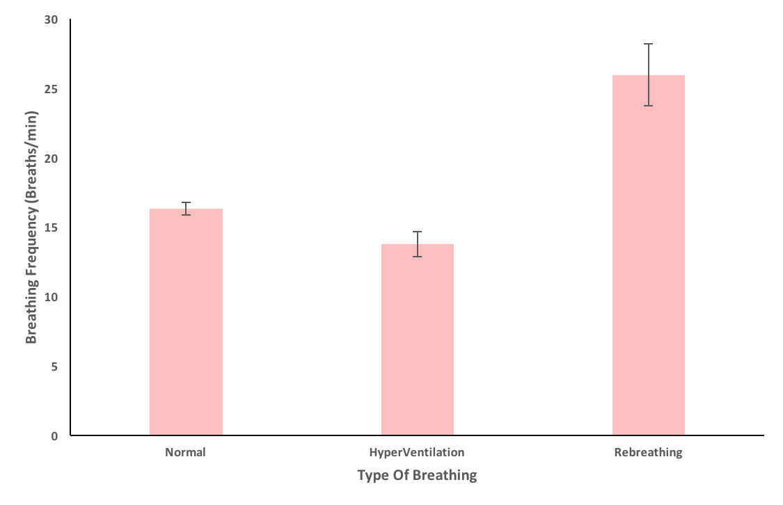

Figure 6: Bar graph displays the breathing frequency (in breaths/minute) for subject after normal respiration, hyperventilating, and immediately after hyperventilation.

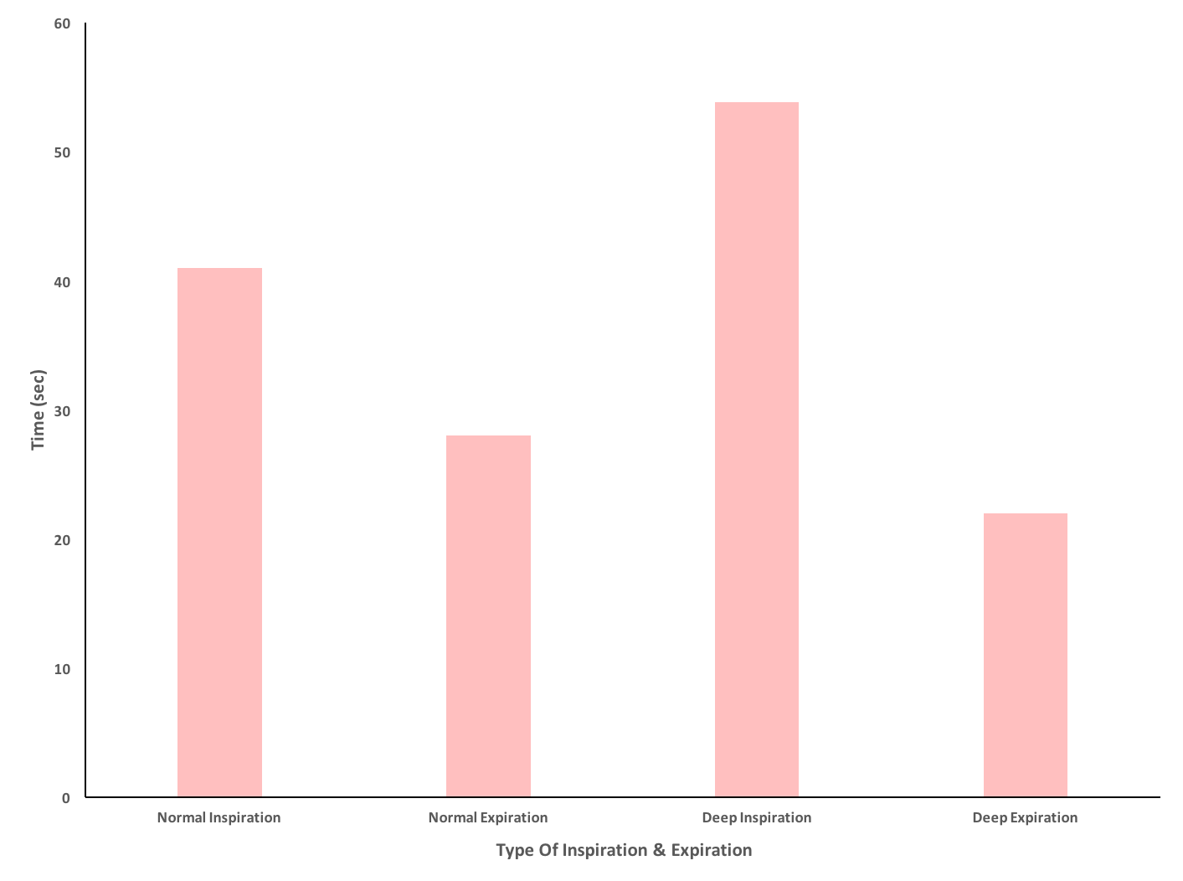

Figure 7: Bar graph displays the type of inspiration and expiration versus time (in seconds) for the subject.

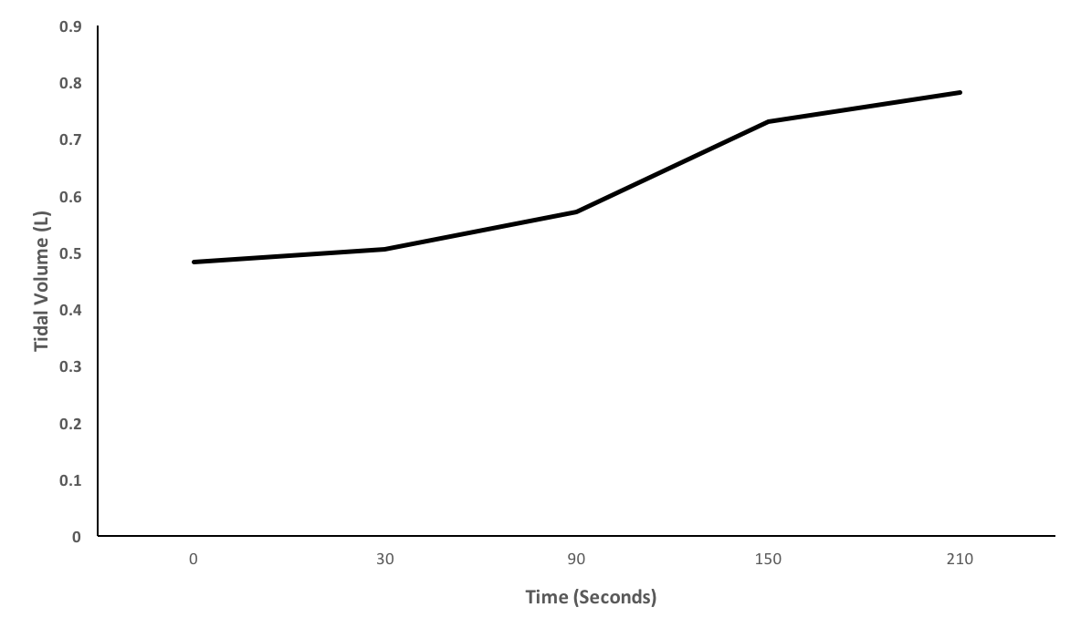

Figure 8: Line graph plots the relationship between time (in seconds) versus tidal volume (in liters) for subject, immediately after completing a physical activity (cycling).

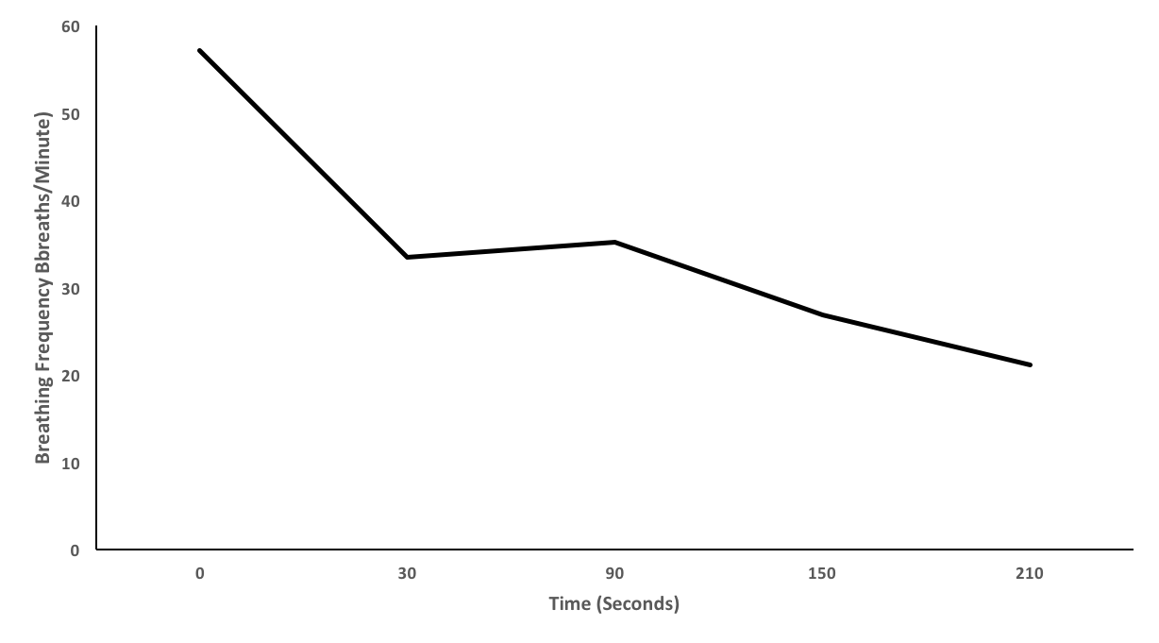

Figure 9: Line graph displays breathing frequency (in breathes/minute) versus time (in seconds) for subject undergoing a physical activity (exercise cycle).

**Discussion**

[1]The vital capacity is greater than the resting tidal volume. Please refer to Figure 1. This indicates that the respiratory system is able to increase breathing when demand for gas exchange increases. This is because the vital capacity is the greatest amount of air that can be expelled from the lungs after taking the deepest breath possible, and tidal volume is the normal amount of air that is displaced between breathes (i.e. between normal inhalation and normal exhalation). Since vital capacity is greater than tidal volume, the lungs can output more gas when and if demand were to increase. This increase in demand can be due to rigorous activity/exercise. Furthermore, tidal volume is approximately 1.5 litres, and vital capacity is around 3.2 litres. Please refer to Figure 1. If needed, the lungs can drastically increase breathing frequency.

[2] When the subject was asked to mentally recite the alphabets in reverse order, the subject’s breathing frequency drastically decreased from around 20 breaths/minute to around 7.6 breaths/minute. Breathing frequency decreased by more than a factor of 2. Please refer to figure 4. This demonstrates that the inputs to the respiratory centers from the cerebral cortex is not only limited to controlling respiration but other functions as well. The medulla oblongata, the pons, and the midbrain are responsible for controlling the rate of respiration (Chiari et al). Furthermore, in order to process complicated tasks, the brain pulls resources from one area and dedicates them to another. In this case, breathing frequency rapidly decreased in order to process the alphabet backwards, and mentally recite it.

[3] After hyperventilating for a few minutes, the subject’s rebreathing phase showed an increase in both average tidal volume (in liters) and breathing frequency. Please refer to Figures 5 and 6 for results. This is because after taking short breaths for a prolonged period of time, the tissues in the body don’t receive enough oxygen during the hyperventilation stage. The lungs only fill up with a tiny fraction of air, and there is lots of waste to expel. The subsequent breathing and tidal volume after hyperventilating dramatically increases because the body needs to supply oxygen to all the tissues and expel the waste. Also, apnea does not develop. After hyperventilating, the brain signals the body to stop hyperventilating and continue breathing normally. At this stage, the breathing frequency increases to meet oxygen demands and eventually lowers and reaches a relatively neutral state.

[4] Breathing frequency and tidal volume increased after re-breathing, while the arterial partial pressure of CO2 was elevated above normal. This is because during this stage, the body needs more oxygen in order to reach relatively normal/neutral levels, and in order to do so, it innervates the respiratory system and sends signals to increase breathing frequency and tidal volume to reach optimal oxygen levels.

[5] Low oxygen has a more powerful effect on breathing than high carbon dioxide. This is because during low oxygen levels the human body cannot maintain function. Areas such as muscles become numb and the human body can experience symptoms such as headache, nausea, dizziness, confusion, blurred vision, and loss of consciousness (Stanfield et al). While high carbon dioxide levels innervate the heart and respiratory system by stimulating them and making them work harder. The heart starts to pump more blood to remove the excess carbon dioxide and the respiratory system increases breathing frequency to take in more oxygen to supply it to the muscles and tissues, and where required in the body.

[6] In exercise 5, voluntary apnea is the longest after hyper-ventilation. This is because once the body meets its required supply of oxygen it dramatically slows down breathing to stabilize the oxygen levels (Gehr et al). Thus, signals are sent to the respiratory system to innervate the organs and slow down the intake of oxygen until levels are normal/neutral.

[7] Exercise increases breathing drastically to the point the human begins to pant and breathe through their mouth. After exercising, it can take approximately 200 – 300 seconds to recover and reach a state of equilibrium; a state where the body no longer feels tired, but normal instead. Even after exercising, when muscles are no longer contracting, the body will continue to remain elevated and breathing frequency will be high. This is because the body needs to remove excess waste from the tissue and supply fresh oxygen to them (Perry et al). The needs to remove waste such as CO2 and lactic acid from the tissues as quickly as possible, and supply the tissue with fresh oxygen. (Perry et al). In order to keep up with the muscles heavy demand of oxygen, breathing elevates and signals are sent to comply. Thus, after an intense exercise, humans will continue to heavily and rapidly breathe through their nose mouth, to meet the demands of the body.

**References**

McLafferty, E., Johnstone, C., Hendry, C., & Farley, A. (2011, March 3). Respiratory system

part 1: pulmonary ventilation. Retrieved March 20, 2017, from http://journals.rcni.com/doi/abs/10.7748/ns2013.01.27.22.40.e4216

# Perry, S., & Warren, B. (2008, October 1). Why respiratory biology? The meaning and

# significance of respiration and its integrative study? Retrieved March 20, 2017, from https://academic.oup.com/icb/article/47/4/506/631426/Why-respiratory-biology-The-meaning-and

Chiari, L., Avanzolini, G., & Ursino, M. (1997, April 18). A comprehensive simulator of the

human respiratory system: Validation with experimental and simulated data. Retrieved March 20, 2017, from https://link.springer.com/article/10.1007/BF02684134

Gehr, P. (1994, January 1). Annexe A. Anatomy and morphology of the respiratory tract.

Retrieved March 20, 2017, from http://journals.sagepub.com/doi/abs/10.1016/0146-6453(94)90039-6

Stanfield, C. L., & Germann, W. J. (2011). *Principles Of Human Physiology* (4th ed.). San

Francisco, CA: Pearson/Benjamin Cummings.

